Title of Paper: Digital Electronics
Practical List
Practical List | Title of Program
1 | Study of Components: Resistors, Capacitors, Inductors, Diodes, LED’s and Transistors.
2 | Study of Logic Gates with truth table
3 | Study of Half adder and Full adder
4 | Study of Half Subtractor and Full Subtractor
5 | Study of Implementation of 3:8 decoder
6 | Study of 4-line to 16 bit decoder
7 | Study of BCD to 7-Segment decoder
8 | Study of Clocked JK Flip Flop
9 | Study of 4-bit Ripple Counter
10 | Study of Parallel-In , Serial-Out,4-bit shift register

Practical No:1
Aim: Study of Components: Resistors, Capacitors, Inductors, Diodes, LED’s and Transistors.
Resistors:
Resistors are one of the most basic circuit components and are used to limit the flow of electrical current in a circuit. A resistor's resistance is measured in ohms, and the amount of current flowing through a resistor is proportional to the voltage across it and inversely proportional to its resistance.
There are different types of resistors, including carbon composition, wire-wound, and film resistors. Each of the Resistors are essential components in electronic circuits, used for limiting the flow of electrical current in a circuit. The resistance of a resistor is measured in ohms (Ω), and it determines the amount of current flowing through the resistor. The relationship between voltage, current, and resistance is defined by Ohm's law, which states that the current flowing through a resistor is proportional to the voltage across it and inversely proportional to its resistance.

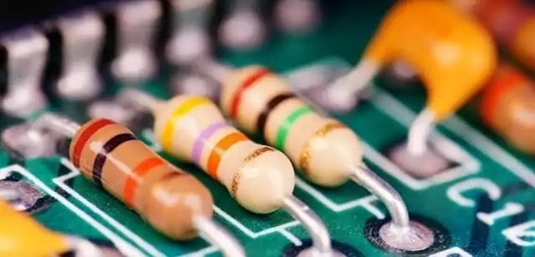
Resistors
Capacitors:
Capacitors are used to store electrical charge and release it when needed in a circuit. They are used in various applications such as filtering, timing circuits, power supplies, and many more.
Capacitance is the measure of the capacitor's ability to store electrical charge, and it is measured in farads. Capacitors come in various sizes and types, including electrolytic capacitors, ceramic capacitors, and tantalum capacitors.
Capacitors are another essential circuit component, used for storing and releasing electrical energy. A capacitor consists of two conductive plates separated by an insulating material, known as the dielectric. The capacitance of a capacitor is determined by the surface area of the plates, the distance between them, and the type of dielectric used.
There are different types of capacitors available in the market, each with its unique properties and advantages. Some of the most common types include ceramic, electrolytic, and tantalum capacitors.
The choice of capacitor type depends on the specific requirements of the circuit and the application. For instance, ceramic capacitors are ideal for high-frequency applications, whereas electrolytic capacitors are better suited for high-capacitance applications.

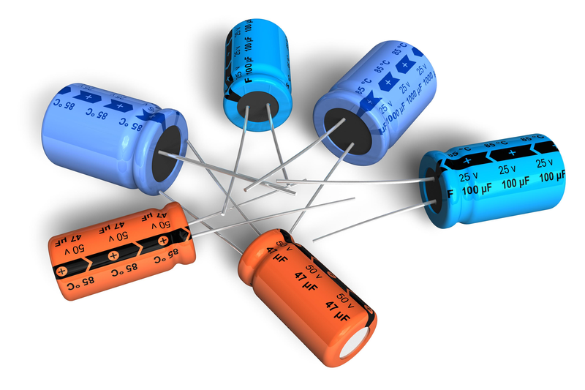
Capacitors

Inductors:
Inductors are an essential component in electronic circuits that play a significant role in storing energy in a magnetic field. The main function of an inductor is to resist changes in the flow of electrical current in a circuit. It achieves this by inducing a back-emf (electromotive force) when the current flowing through it changes. This back-emf opposes the change in current, which helps in stabilizing the current flow in the circuit.
The measure of an inductor's ability to store energy is called inductance. Inductance is measured in Henries and is denoted by the letter "H". In simple terms, the higher the inductance, the more energy an inductor can store in its magnetic field. The inductance of an inductor depends on its physical properties, such as the number of turns in the coil, the size of the coil, and the type of core material used.
Inductors come in different types, each with its unique properties and applications. Air-core inductors are made up of coils of wire without any core material. They have low inductance values and are often used in high-frequency applications, where their low parasitic capacitance is beneficial.
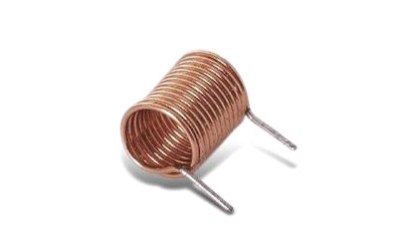
Inductor

Diodes:
Diodes are crucial electronic components that are widely used in various circuits. A diode is a two-terminal device that allows the current to flow in one direction only, and blocks the current flow in the opposite direction. This characteristic of diodes makes them useful in rectifier circuits, where they are used to convert AC (alternating current) to DC (direct current) by allowing only the positive half of the AC waveform to pass through.
A diode has two terminals: the anode and the cathode. The anode is the positive terminal, and the cathode is the negative terminal. When a voltage is applied to the anode of a diode, current flows through the diode in the forward direction, from the anode to the cathode. In this state, the diode has low resistance, and current can flow easily through it.
However, if a voltage is applied to the cathode of the diode, current cannot flow through it in the reverse direction. This state of the diode is called reverse bias, and the diode has a very high resistance to current flow in this state.
There are different types of diodes, each with its unique properties and applications. Rectifier diodes are the most common type of diodes and are used in rectifier circuits to convert AC to DC. Zener diodes are used in voltage regulator circuits to maintain a constant voltage across a load. Light-emitting diodes (LEDs) are used in lighting applications and for indicating the status of electronic circuits.

Diode

Transistors:
Transistors are one of the most essential components in electronic circuits due to their ability to amplify and switch electrical signals. They are commonly used in various applications, including audio amplifiers, radio receivers, and digital circuits. Transistors come in different types, including bipolar junction transistors (BJTs) and field-effect transistors (FETs), each of which has its own unique properties and is suited for different applications.
Bipolar junction transistors (BJTs) are three-layer semiconductor devices with two pn-junctions. They consist of a base, emitter, and collector region. BJTs are often used in analog circuits due to their high current gain and excellent linearity. The base-emitter junction of the BJT is forward-biased, allowing a small current to flow from the emitter to the collector. The amount of current that flows through the collector is proportional to the amount of current flowing into the base. This feature allows BJTs to amplify signals.
Field-effect transistors (FETs) are three-terminal devices that rely on an electric field to control the flow of current. They are often used in digital circuits due to their high input impedance, low output impedance, and fast switching speed. FETs come in two types, junction FETs (JFETs) and metal-oxide-semiconductor FETs (MOSFETs). JFETs have a simple structure, consisting of a semiconductor channel with two pn-junctions. They are commonly used in low-noise amplifier circuits due to their low noise characteristics. MOSFETs have a more complex structure and are commonly used in high-speed digital circuits due to their fast switching speed.
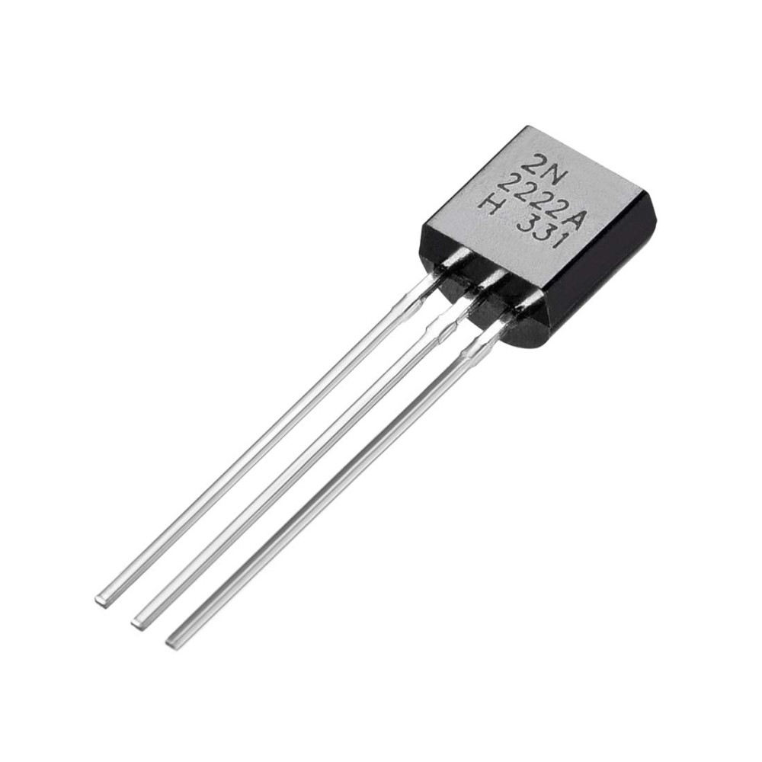
Transistor

Practical No-2
Aim: Study of Logic Gates with truth table
What is a Logic Gate?
A logic gate is an electronic circuit designed by using electronic components like diodes, transistors, resistors, and more. As the name implies, a logic gate is designed to perform logical operations in digital systems like computers, communication systems, etc.
The logic gates can be classified into the following major types:
- Basic Logic Gates – There are three basic logic gates:
  - AND Gate
  - OR Gate
  - NOT Gate
- Universal Logic Gates – In digital electronics, the following two logic gates are considered as universal logic gates:
  - NOR Gate
  - NAND Gate
- Derived Logic Gates – The following two are the derived logic gates used in digital systems:
  - XOR Gate
  - XNOR Gate
1. Basic Logic Gates

a) AND Gate
In digital electronics, the AND gate is one of the basic logic gate that performs the logical multiplication of inputs applied to it. It generates a high or logic 1 output, only when all the inputs applied to it are high or logic 1. Otherwise, the output of the AND gate is low or logic 0.

Truth Table of AND Gate:
The truth table of a two input AND gate is given below:
Input |  | Output
A | B | A AND B
0 | 0 | 0
0 | 1 | 0
1 | 0 | 0
1 | 1 | 1

Symbol of AND Gate:
The logic symbol of a two input AND gate is shown in the following figure.
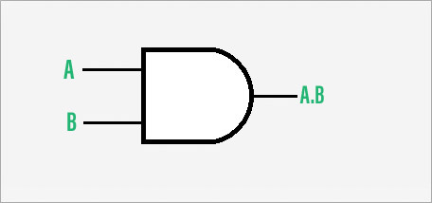
Symbol of Two-Input AND Gate
b) OR Gate
In digital electronics, there is a type of basic logic gate which produces a low or logic 0 output only when its all inputs are low or logic 0. For all other input combinations, the output of the OR gate is high or logic 1. This logic gate is termed as OR gate. An OR gate can be designed to have two or more inputs but only one output. The primary function of the OR gate is to perform the logical sum operation.

Truth Table of OR Gate:
The truth table of an OR gate describes the relationship between inputs and output. The following is the truth table for the two-input OR gate:

Input |  | Output
A | B | A OR B
0 | 0 | 0
0 | 1 | 1
1 | 0 | 1
1 | 1 | 1
Symbol of OR Gate:
The logic symbol of a two-input OR gate is shown in the following figure.
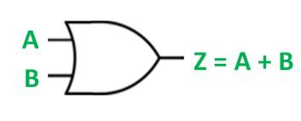
Symbol of Two-Input OR Gate
c) NOT Gate
In digital electronics, the NOT gate is another basic logic gate used to perform compliment of an input signal applied to it. It takes only one input and one output. The output of the NOT gate is complement of the input applied to it. Therefore, if we apply a low or logic 0 output to the NOT gate is gives a high or logic 1 output and vice-versa. The NOT gate is also known as inverter, as it performs the inversion operation.
Truth Table of NOT Gate:
The truth table describes the relationship between input and output. The following is the truth table for the NOT gate:
Input | Output
A | NOT A
0 | 1
1 | 0
Symbol of NOT Gate
The logic circuit symbol of a NOT gate is shown in the following figure. Here, A is the input line and Z is the output line.
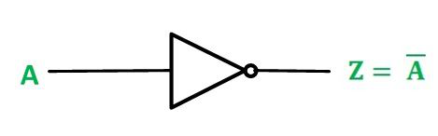

2) Universal Logic Gates
a) NOR Gate
The NOR gate is a type of universal logic gate that can take two or more inputs but one output. It is basically a combination of two basic logic gates i.e., OR gate and NOT gate. Thus, it can be expressed as,
NOR Gate = OR Gate + NOT Gate
In other words, a NOR gate is an OR gate followed by a NOT gate.
Truth Table of NOR Gate:
The following is the truth table of a two-input NOR gate showing the relationship between its inputs and output:
Input |  | Output
A | B | A NOR B
0 | 0 | 1
0 | 1 | 0
1 | 0 | 0
1 | 1 | 0
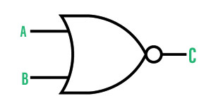
Symbol of the NOR Gate
b) NAND Gate
In digital electronics, the NAND gate is another type of universal logic gate used to perform logical operations. The NAND gate performs the inverted operation of the AND gate. Similar to NOR gate, the NAND gate can also have two or more input lines but only one output line.
The NAND gate is also represented as a combination of two basic logic gates namely, AND gate and NOT gate. Hence, it can be expressed as
NAND Gate = AND Gate + NOT Gate
Truth Table of NAND Gate:
The truth table is a table of inputs and output that describes the operation of the NAND gate and shows the logical relationship between them:

Input |  | Output
A | B | A NAND B
0 | 0 | 1
0 | 1 | 1
1 | 0 | 1
1 | 1 | 0
Symbol of NAND Gate:
The logic symbol of a NAND gate is represented as a AND gate with a bubble on its output end as depicted in the following figure. It is the symbol of a two-input NAND gate.
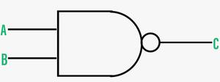
Symbol of NAND Gate
3) Derived Logic Gates
a) XOR Gate
In digital electronics, there is a specially designed logic gate named, XOR gate, which is used in digital circuits to perform modulo sum. It is also referred to as Exclusive OR gate or Ex-OR gate. The XOR gate can take only two inputs at a time and give an output. The output of the XOR gate is high or logic 1 only when its two inputs are dissimilar.
Truth Table of XOR Gate:
The truth table is a table of inputs and output that describe the relationship between them and the operation of the XOR gate for different input combinations. The truth table of the XOR gate is given below:
Input |  | Output
A | B | A XOR B
0 | 0 | 0
0 | 1 | 1
1 | 0 | 1
1 | 1 | 0

Symbol of XOR Gate:
The logic symbol of an XOR gate is shown in the following figure.

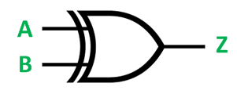
Symbol of XOR Gate
b) XNOR Gate
The XNOR gate is another type of special purpose logic gate used to implement exclusive operation in digital circuits. It is used to implement the Exclusive NOR operation in digital circuits. It is also called the Ex-NOR or Exclusive NOR gate. It is a combination of two logic gates namely, XOR gate and NOT gate. Thus, it can be expressed as,
XNOR Gate = XOR Gate + NOT Gate
The output of an XNOR gate is high or logic 1 when its both inputs are similar. Otherwise the output is low or logic 0. Hence, the XNOR gate is used as a similarity detector circuit.
Truth Table of XNOR Gate:
The truth table of the XNOR gate is given below. This truth table is describing the relationship between inputs and output of the XNOR gate.

Input |  | Output
A | B | A XNOR B
0 | 0 | 1
0 | 1 | 0
1 | 0 | 0
1 | 1 | 1
Symbol of XNOR Gate:
The logic symbol of XNOR gate is shown in the following figure. Here, A and B are inputs and Y is the output.
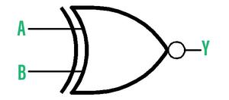
Symbol of XNOR gate

Practical No:3
Aim: Study of Half adder and Full adder
Half Adder : Half Adder is a combinational logic circuit which is designed by connecting one EX-OR gate and one AND gate. The half adder circuit has two inputs: A and B, which add two input digits and generates a carry and a sum.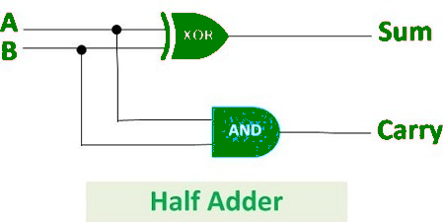
The output obtained from the EX-OR gate is the sum of the two numbers while that obtained by AND gate is the carry. There will be no forwarding of carry addition because there is no logic gate to process that. Thus, this is called the Half Adder circuit.
Logical Expression :
Sum = A XOR B
Carry = A AND B
Truth Table :
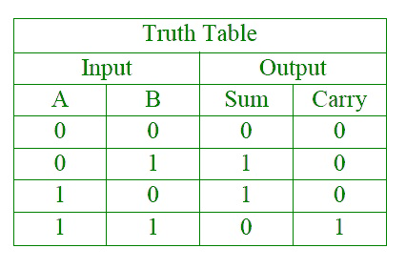
. Full Adder: Full Adder is the circuit that consists of two EX-OR gates, two AND gates, and one OR gate. Full Adder is the adder that adds three inputs and produces two outputs which consist of two EX-OR gates, two AND gates, and one OR gate. The first two inputs are A and B and the third input is an input carry as C-IN. The output carry is designated as C-OUT and the normal output is designated as S which is SUM.
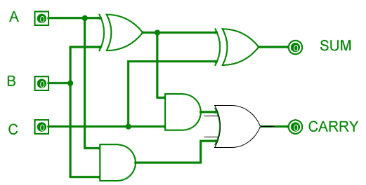
The equation obtained by the EX-OR gate is the sum of the binary digits. While the output obtained by AND gate is the carry obtained by addition.
Truth Table:
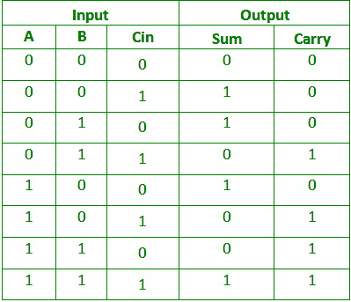

Practical No:4
Aim: Study of Half Subtractor and Full Subtractor
Half Subtractor
Half subtractor is a combination circuit with two inputs and two outputs that are different and borrow. It produces the difference between the two binary bits at the input and also produces an output (Borrow) to indicate if a 1 has been borrowed. In the subtraction (A-B), A is called a Minuend bit and B is called a Subtrahend bit.
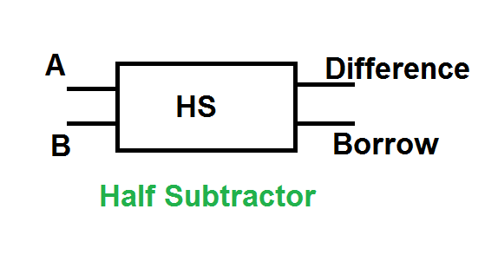

Truth Table
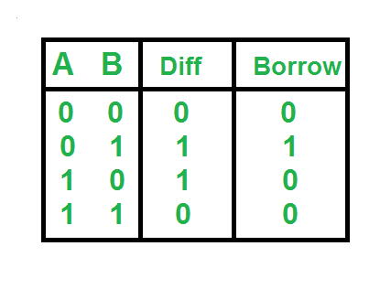
The SOP form of the Diff and Borrow is as follows:
Diff= A'B+AB'
Borrow = A'B
Implementation
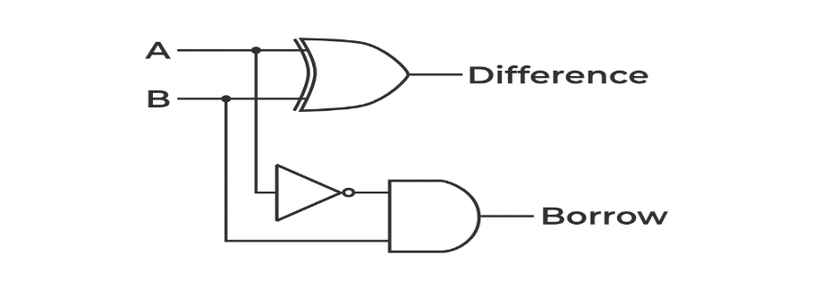

Logical Expression
Difference = A XOR B
Borrow = \overline{A}B
Full Subtractor
A full subtractor is a combinational circuit that performs subtraction of two bits, one is minuend and other is subtrahend, taking into account borrow of the previous adjacent lower minuend bit. This circuit has three inputs and two outputs. The three inputs A, B and Bin, denote the minuend, subtrahend, and previous borrow, respectively. The two outputs, D and Bout represent the difference and output borrow, respectively. Although subtraction is usually achieved by adding the complement of subtrahend to the minuend, it is of academic interest to work out the Truth Table and logic realisation of a full subtractor; x is the minuend; y is the subtrahend; z is the input borrow; D is the difference; and B denotes the output borrow. The corresponding maps for logic functions for outputs of the full subtractor namely difference and borrow.
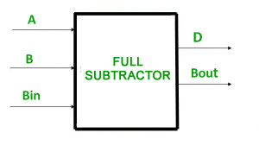

Truth Table –
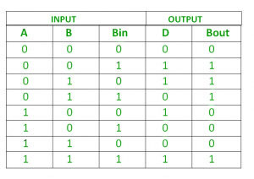
Logic Circuit for Full Subtractor –

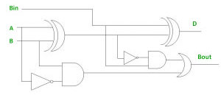

Practical No:5
Aim: Study of Implementation of 3:8 decoder
3 to 8 line decoder:
The 3 to 8 line decoder is also known as Binary to Octal Decoder. In a 3 to 8 line decoder, there is a total of eight outputs, i.e., Y₀, Y₁, Y₂, Y₃, Y₄, Y₅, Y₆, and Y₇ and three outputs, i.e., A₀, A1, and A₂. This circuit has an enable input 'E'. Just like 2 to 4 line decoder, when enable 'E' is set to 1, one of these four outputs will be 1. The block diagram and the truth table of the 3 to 8 line encoder are given below.
Block Diagram:
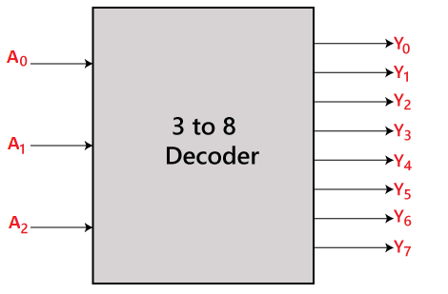
Truth Table:
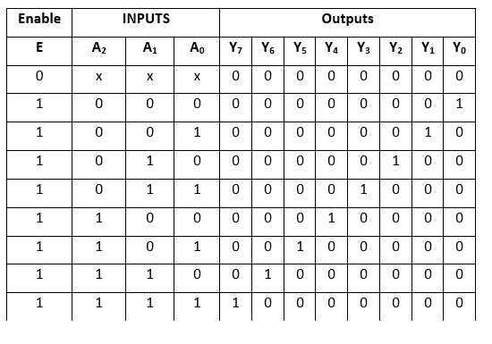
The logical expression of the term Y₀, Y₁, Y₂, Y₃, Y₄, Y₅, Y₆, and Y₇ is as follows:
Y₀=A₀'.A₁'.A₂'
Y₁=A₀.A₁'.A₂'
Y₂=A₀'.A₁.A₂'
Y₃=A₀.A₁.A₂'
Y₄=A₀'.A₁'.A₂
Y₅=A₀.A₁'.A₂
Y₆=A₀'.A₁.A₂
Y₇=A₀.A₁.A₂
Logical circuit of the above expressions is given below:
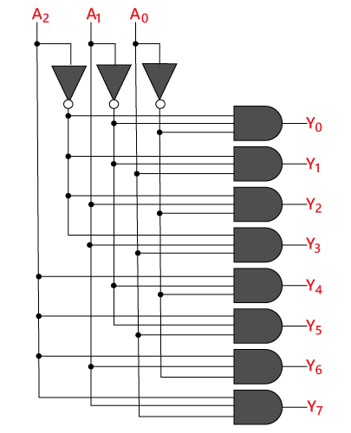

Practical No:6
Aim: Study of 4-line to 16 bit decoder
4 to 16 line Decoder:
In the 4 to 16 line decoder, there is a total of 16 outputs, i.e., Y₀, Y₁, Y₂,……, Y₁₆ and four inputs, i.e., A₀, A1, A₂, and A₃. The 3 to 16 line decoder can be constructed using either 2 to 4 decoder or 3 to 8 decoder. There is the following formula used to find the required number of lower-order decoders.
Required number of lower order decoders=m₂/m₁
m₁ = 8
m₂ = 16
Required number of 3 to 8 decoders==2
Block Diagram:
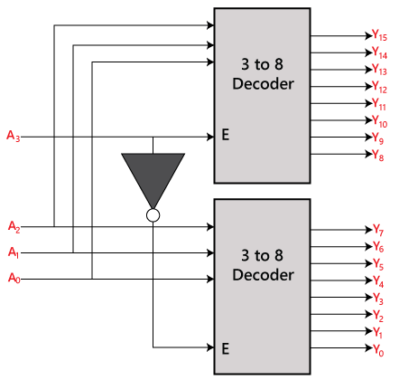
Truth Table:
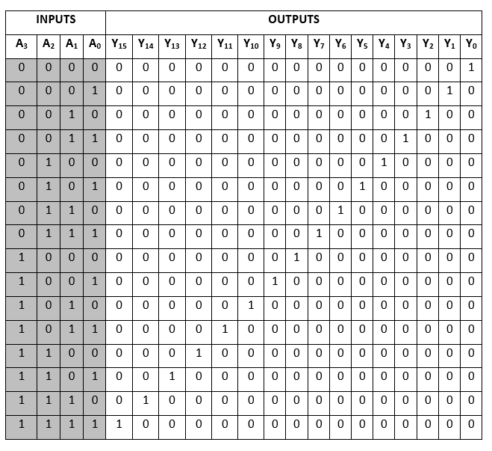
The logical expression of the term A0, A1, A2,…, A15 are as follows:
Y₀=A₀'.A₁'.A₂'.A₃'
Y₁=A₀'.A₁'.A₂'.A₃
Y₂=A₀'.A₁'.A₂.A₃'
Y₃=A₀'.A₁'.A₂.A₃
Y₄=A₀'.A₁.A₂'.A₃'
Y₅=A₀'.A₁.A₂'.A₃
Y₆=A₀'.A₁.A₂.A₃'
Y₇=A₀'.A₁.A₂.A₃
Y₈=A₀.A₁'.A₂'.A₃'
Y₉=A₀.A₁'.A₂'.A₃
Y₁₀=A₀.A₁'.A₂.A₃'
Y₁₁=A₀.A₁'.A₂.A₃
Y₁₂=A₀.A₁.A₂'.A₃'
Y₁₃=A₀.A₁.A₂'.A₃
Y₁₄=A₀.A₁.A₂.A₃'
Y₁₅=A₀.A₁.A₂'.A₃
Logical circuit of the above expressions is given below:
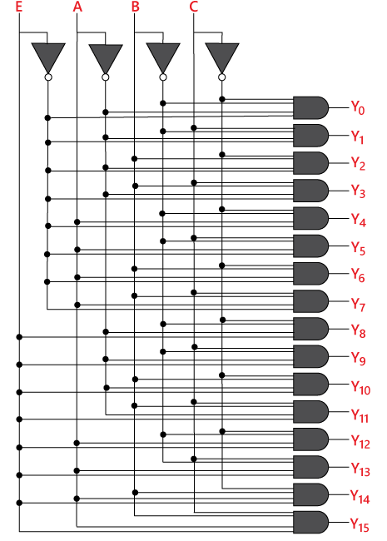
Practical No:7
Aim: Study of BCD to 7-Segment decoder
The seven-segment decoder, which has four input lines and seven output lines (a, b, c, d, e, f, and g), receives this BCD (A, B, C, and D) input. The output is provided to a seven-segment LED display that shows the decimal number depending on the inputs.
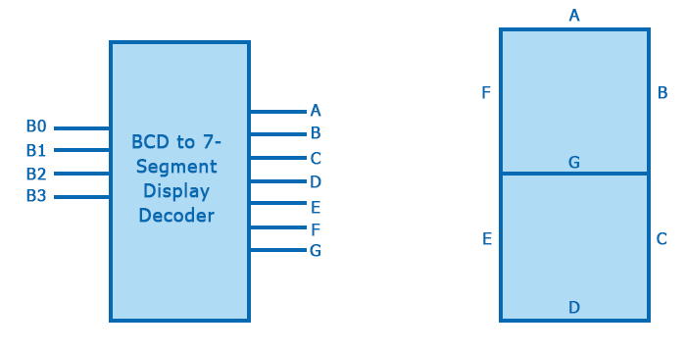
The truth table of Common Cathode Type BCD to the seven-segment decoder is given below:
Decimal Number | INPUT Lines |  |  |  | OUTPUT Lines
Decimal Number | A | B | C | D | a | b | c | d | e | f | g
0 | 0 | 0 | 0 | 0 | 1 | 1 | 1 | 1 | 1 | 1 | 0
1 | 0 | 0 | 0 | 1 | 0 | 1 | 1 | 0 | 0 | 0 | 0
2 | 0 | 0 | 1 | 0 | 1 | 1 | 0 | 1 | 1 | 0 | 1
3 | 0 | 0 | 1 | 1 | 1 | 1 | 1 | 1 | 0 | 0 | 1
4 | 0 | 1 | 0 | 0 | 0 | 1 | 1 | 0 | 0 | 1 | 1
5 | 0 | 1 | 0 | 1 | 1 | 0 | 1 | 1 | 0 | 1 | 1
6 | 0 | 1 | 1 | 0 | 1 | 0 | 1 | 1 | 1 | 1 | 1
7 | 0 | 1 | 1 | 1 | 1 | 1 | 1 | 0 | 0 | 0 | 0
8 | 1 | 0 | 0 | 0 | 1 | 1 | 1 | 1 | 1 | 1 | 1
9 | 1 | 0 | 0 | 1 | 1 | 1 | 1 | 1 | 0 | 1 | 1
Important points:
- For a seven-segment LED display of the Common Anode type, all we need to do is swap all of the '0's and '1's on the output side, i.e., for a, b, c, d, e, f, and g, swap all of the '1's for '0's, and use k-map to solve.
- In the above truth table, the combinations of inputs represent the digits from 0 to 1.
- The range of BCD numbers is 0 to 9, and the rest of the inputs are invalid.
Let us now understand the few inputs:
For Decimal Number = 0
The input lines for Zero are A = 0, B = 0, C = 0, and D = 0 and in the output lines, a to f are 1 and only g = 0. So, the g LED display will not glow, and the rest of the LEDs will glow, and we get zero on display.
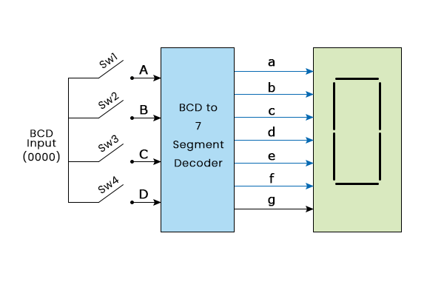
For Decimal Number = 2
The input lines for two are A = 0, B = 0, C = 1, and D = 0; in the output lines, a, b, d, e, and g are 1 and c and f are zero. So, only a, b, d, e, and g will glow, and we get two on display.
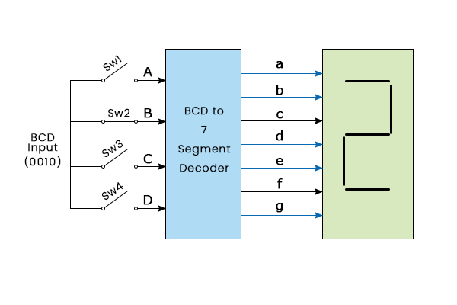

Practical No:8
Aim: Study of Clocked JK Flip Flop
JK Flip Flop:
The SR Flip Flop or Set-Reset flip flop has lots of advantages. But, it has the following switching problems:
- When Set 'S' and Reset 'R' inputs are set to 0, this condition is always avoided.
- When the Set or Reset input changes their state while the enable input is 1, the incorrect latching action occurs.
The JK Flip Flop removes these two drawbacks of SR Flip Flop.
The JK flip flop is one of the most used flip flops in digital circuits. The JK flip flop is a universal flip flop having two inputs 'J' and 'K'. In SR flip flop, the 'S' and 'R' are the shortened abbreviated letters for Set and Reset, but J and K are not. The J and K are themselves autonomous letters which are chosen to distinguish the flip flop design from other types.
The JK flip flop work in the same way as the SR flip flop work. The JK flip flop has 'J' and 'K' flip flop instead of 'S' and 'R'. The only difference between JK flip flop and SR flip flop is that when both inputs of SR flip flop is set to 1, the circuit produces the invalid states as outputs, but in case of JK flip flop, there are no invalid states even if both 'J' and 'K' flip flops are set to 1.
The JK Flip Flop is a gated SR flip-flop having the addition of a clock input circuitry. The invalid or illegal output condition occurs when both of the inputs are set to 1 and are prevented by the addition of a clock input circuit. So, the JK flip-flop has four possible input combinations, i.e., 1, 0, "no change" and "toggle". The symbol of JK flip flop is the same as SR Bistable Latch except for the addition of a clock input.
Block Diagram:
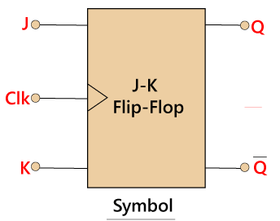
Circuit Diagram:
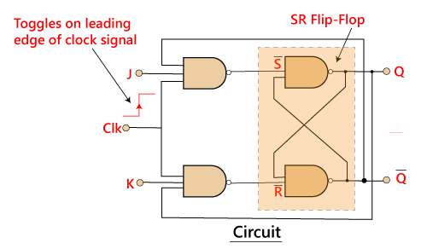
In SR flip flop, both the inputs 'S' and 'R' are replaced by two inputs J and K. It means the J and K input equates to S and R, respectively.
The two 2-input AND gates are replaced by two 3-input NAND gates. The third input of each gate is connected to the outputs at Q and Q'. The cross-coupling of the SR flip-flop permits the previous invalid condition of (S = "1", R = "1") to be used to produce the "toggle action" as the two inputs are now interlocked.
If the circuit is "set", the J input is interrupted from the "0" position of Q' through the lower NAND gate. If the circuit is "RESET", K input is interrupted from 0 positions of Q through the upper NAND gate. Since Q and Q' are always different, we can use them to control the input. When both inputs 'J' and 'K' are set to 1, the JK toggles the flip flop as per the given truth table.
Truth Table:
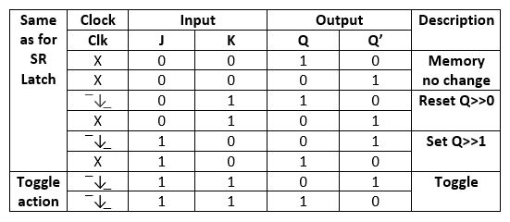
When both of the inputs of JK flip flop are set to 1 and clock input is also pulse "High" then from the SET state to a RESET state, the circuit will be toggled. The JK flip flop work as a T-type toggle flip flop when both of its inputs are set to 1.
The JK flip flop is an improved clocked SR flip flop. But it still suffers from the "race" problem. This problem occurs when the state of the output Q is changed before the clock input's timing pulse has time to go "Off". We have to keep short timing plus period (T) for avoiding this period.

Practical No:9

Aim: Study of 4-bit Ripple Counter
What is a Ripple counter?
Ripple counter is a cascaded arrangement of flip-flops where the output of one flip-flop drives the clock input of the following flip-flop. The number of flip flops in the cascaded arrangement depends upon the number of different logic states that it goes through before it repeats the sequence a parameter known as the modulus of the counter. A n-bit ripple counter can count up to 2n states. It is also known as MOD n counter. It is known as ripple counter because of the way the clock pulse ripples its way through the flip-flops. Some of the features of ripple counter are:
- It is an asynchronous counter.
- Different flip-flops are used with a different clock pulse.
- All the flip-flops are used in toggle mode.
- Only one flip-flop is applied with an external clock pulse and another flip-flop clock is obtained from the output of the previous flip-flop.
- The flip-flop applied with an external clock pulse act as LSB (Least Significant Bit) in the counting sequence.
A counter may be an up counter that counts upwards or can be a down counter that counts downwards or can do both i.e.count up as well as count downwards depending on the input control. The sequence of counting usually gets repeated after a limit. When counting up, for the n-bit counter the count sequence goes from 000, 001, 010, … 110, 111, 000, 001, … etc. When counting down the count sequence goes in the opposite manner: 111, 110, … 010, 001, 000, 111, 110, … etc.
A 3-bit Ripple counter using a JK flip-flop is as follows:
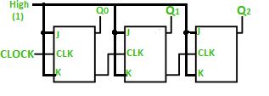
In the circuit shown in the above figure, Q0(LSB) will toggle for every clock pulse because JK flip-flop works in toggle mode when both J and K are applied 1, 1, or high input. The following counter will toggle when the previous one changes from 1 to 0.
Truth Table is as follows:
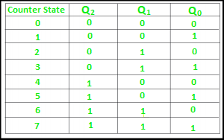
The 3-bit ripple counter used in the circuit above has eight different states, each one of which represents a count value. Similarly, a counter having n flip-flops can have a maximum of 2 to the power n states. The number of states that a counter owns is known as its mod (modulo) number. Hence a 3-bit counter is a mod-8 counter. A mod-n counter may also be described as a divide-by-n counter. This is because the most significant flip-flop (the furthest flip-flop from the original clock pulse) produces one pulse for every n pulses at the clock input of the least significant flip-flop (the one triggers by the clock pulse). Thus, the above counter is an example of a divide-by-4 counter.
Timing diagram
Let us assume that the clock is negative edge triggered so the above the counter will act as an up counter because the clock is negative edge triggered and output is taken from Q.
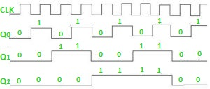
Counters are used very frequently to divide clock frequencies and their uses mainly involve digital clocks and in multiplexing. The widely known example of the counter is parallel to serial data conversion logic.

Practical No:10
Aim: Study of Parallel-In, Serial-Out,4-bit shift register
Shift Register:
A group of flip flops which is used to store multiple bits of data and the data is moved from one flip flop to another is known as Shift Register. The bits stored in registers shifted when the clock pulse is applied within and inside or outside the registers. To form an n-bit shift register, we have to connect n number of flip flops. So, the number of bits of the binary number is directly proportional to the number of flip flops. The flip flops are connected in such a way that the first flip flop's output becomes the input of the other flip flop.
A Shift Register can shift the bits either to the left or to the right. A Shift Register, which shifts the bit to the left, is known as "Shift left register", and it shifts the bit to the right, known as "Right left register".
Parallel IN Serial OUT
In the "Parallel IN Serial OUT" register, the data is entered in a parallel way, and the outcome comes serially. A four-bit "Parallel IN Serial OUT" register is designed below. The input of the flip flop is the output of the previous Flip Flop. The input and outputs are connected through the combinational circuit. Through this combinational circuit, the binary input B₀, B₁, B₂, B₃ are passed. The shift mode and the load mode are the two modes in which the "PISO" circuit works.
Load mode
The bits B₀, B₁, B₂, and B₃ are passed to the corresponding flip flops when the second, fourth, and sixth "AND" gates are active. These gates are active when the shift or load bar line set to 0. The binary inputs B0, B1, B2, and B3 will be loaded into the respective flip-flops when the edge of the clock is low. Thus, parallel loading occurs.
Shift mode
The second, fourth, and sixth gates are inactive when the load and shift line set to 0. So, we are not able to load data in a parallel way. At this time, the first, third, and fifth gates will be activated, and the shifting of the data will be left to the right bit. In this way, the "Parallel IN Serial OUT" operation occurs.
Block Diagram
